**DIGITAL MARKETING DATA VISUALIZATION FOR INSURANCE AGGREGATOR**

`

**SHRESHTHA JHA**

**SXJ180082**

**Table of Content**

**Topic Page No.**

1. Source Data Files 3
2. Data Cleaning and Preparation 3
3. Index of Visualization and their respective Data Encoding 5
4. Rationale behind choosing the specific data encoding 6
5. Discussion of the storyline chosen 10
6. Visual data narrative process 11
7. Description of Insights 15

**Source Data Files:**

We have worked on the Primary and Secondary datasets which are Google AdWords and Google Analytics data respectively (more than 5000 records each). As the data files are obtained directly from the Web Analytics Project clients, hence no source link is available for them. (Raw files will be shared over the email if required)

**Data Cleaning and Preparation:**

The initial process was the cleaning and processing of the primary and secondary datasets respectively. The primary dataset (AdWords Data) contained more than 8500 records and the secondary dataset (Analytics Data) had 5000 records. New variables such as Keyword type, Campaign type were created for a more detailed data visualization. The dataset contains records from Jan 2018 to June 2018. The major focus of the data set is on the 2-wheeler car insurance. These datasets were combined into a single excel file using Excel functions like VLOOKUP, SUMIFS, amongst others.

**The aggregated dataset had the following attributes present:**

**Month-Year:** Combination of Month and Year of the dataset.

**Month:** This is a month number column.

**Keyword:** Keywords are the words or phrases that describe a product or service. The keywords help to determine when and where an ad can appear.

**Keyword Type:** These are parameters that are set on the keywords to control the appearance of ads with a search trigger. These are classified as Broad match (helps reaching the widest audience), Exact match (when the exact search keywords are typed), Phrase (ads will appear only when the user searches the exact keyword phrase).

**Keyword Theme:** The category or theme in which a keyword belongs, for ex: Online, Policies, etc.

**Campaign:** Campaigns are used to organize categories of products or services that an ad is promising to offer.

**Campaign Type:** There are generally two campaigns in AdWords: Search Network and Display Network. Search Network is a group of search related websites that are potential for the occurrence of an ad. Display Network helps to reach people while they’re browsing their favorite websites. The dataset is based on the Search Network campaign types for the following 2-wheeler insurance aggregators: Brand Partners, Brand Turtlemint (the brand that we are working for), Competitor, Generic.

**Ad Groups:** An ad group is comprised of one or more ads which target a shared set of keywords.

**Clicks:** Whenever a user clicks on an ad (blue headings on Google), it is counted as a click irrespective of the user reaching the website or not.

**Impressions:** An impression is counted whenever an ad is displayed on a search result page or other site. Each time the ad appears on the Google Network, an impression is counted.

**Click Through Rate (CTR):** It is a statistical measure that shows the performance of an ad and keyword. It calculates the ratio of people seeing the ad and clicking it. It is calculated as: Clicks/Impressions

**Average Cost per Click (CPC):** It is defined as an average amount that has been charged to a company for a click on its ad.

It is calculated by the total costs of clicks **divided by** total number of clicks.

**Cost:** The cost associated with an ad campaign.

**Conversion rate:** It is defined as the average number of conversions (when a user interacts with the ad) per ad click. It is designated as a percentage.

**Average position:** It is a statistical measure that describes how an ad is ranked against other ads. This rank determines in which order ads appear on the page.

**Sessions:** A session is a group of interactions one user takes within a given time frame.

**Conversion:** It shows what happens after a customer/user clicks on an ad. In our case conversion will be defined by the purchase of the 2-wheeler insurance.

**GA Transactions:** A transaction represents the entire transaction that occurs on your site. It means purchase orders.

**Bounced Session:** It is defined as a session which was not completed.

**Bounce rate:** Bounce rate is single-page sessions. Technically, it is the percentage of all sessions on the site in which users viewed only a single page and triggered a single request to the server.

**Cumulative Average Position:** It is the sum of all the average positions related to an ad against all the other ads.

The highlighted records were not present in the dataset and were calculated using specific methodologies.

**Index of Visualization and their respective Data Encoding:**

|  |  |  |
| --- | --- | --- |
| **S.no.** | **Visualization** | **Data Encoding used** |
| 1. | Monthly Overview of Two-Wheeler Insurance Aggregator (Search Campaigns) | Bar Chart and Line Chart |
| 2. | Impressions Trend Across Campaign Type and Months | Area Chart |
| 3. | Campaign Level Conversion vs Conversion Rate | Bar Chart and Line Chart |
| 4. | Campaign Level Conversion vs Cost Per Click (CPC) & Click Through Rate (CTR) | Line Chart |
| 5. | Keyword Type Data: Clicks vs Conversions | Bar Chart and Line Chart |
| 6. | Top 5 performing keywords based on match levels | Treemap |
| 7. | Keyword Conversions based on Campaign type (Brand, Brand Partners, Competitor & Generic) | Bubble Chart |
| 8. | Clicks vs Conversions for Generic Keyword Themes | Bar Chart and Line Chart |
| 9. | Campaign Type Average Position across Months | Bar Chart and Line Chart |
| 10. | Keyword Type and respective Average Bounce Rates | Bar Chart and Line Chart |
| 11. | Campaign type and respective Bounce rates | Area Chart and Line Chart |

**Rationale behind choosing the specific data encoding for Data Visualization**

1. Monthly Overview of Two-Wheeler Insurance Aggregator (Search Campaigns) using **Bar Chart and Line Chart**:

We wanted to visualize the 2 most important attributes namely Clicks and Conversions on all the campaign types, therefore line and bar chart was the most suitable in this case. These two parameters were plotted against the months thereby allowing us to easily compare the total clicks and conversions for the 2-wheeler Insurance aggregators taking place from Jan 2018 to June 2018.

1. Impressions Trend Across Campaign Type and Months using **AreaChart:**

An area chart is best used to depict a time-series relationship. Here, we wanted to communicate the magnitude of impressions (trends of impressions) for the different campaign types, making the Area Chart the best suited technique to visualize this data.

1. Campaign Level Conversion vs Conversion Rateusing **Bar Chart and Line Chart**:

When our data has two data attributes to be visualized against a single variable, it is most convenient to use Bar and Line Chart by adding a second axis. In this visualization, we wanted to compare the Conversion level and Conversion rate for every month among different campaign types to get a better understanding of these attributes affecting each campaign type.

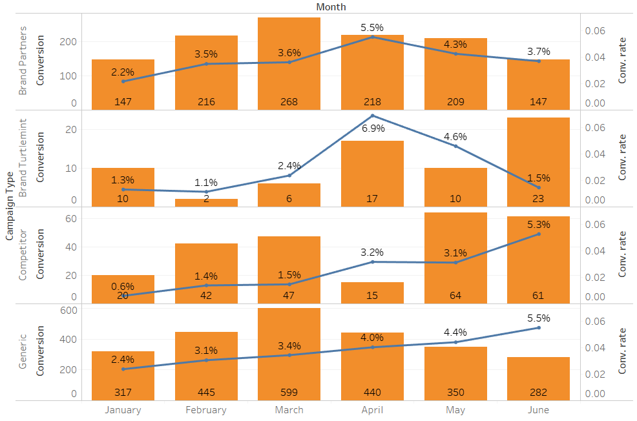

**Fig 1: Screenshot for Visualization 3**

1. Campaign Level Conversion vs Cost Per Click (CPC) & Click Through Rate (CTR) using **Line Chart:**

A line chart is best used when we have a continuous data and wants to observe the trend over a period. In this visualization we wanted to observe two variables: average CPC and CTR over a period of 6 months, henceforth the Line chart was the best suited way of visualizing the data to observe the trends of these variables.

1. Keyword Type Data: Clicks vs Conversionusing **Bar Chart and Line Chart**:

We wanted to visualize Clicks and Conversions against a single variable (month), therefore, the best suited visualization was to use Bar and Line Chart by adding a second axis.

1. Top 5 performing keywords based on match levels using Treemap:

The tree map chart is used for representing data in a tree-like structure. Data is represented using rectangles, the size of each rectangle is based on the value of the dimension under observation. This makes the at-a-glance distinguishing between categories and data values easy. Thus, in our visualizations, the top 5 performing keywords are visualized for different match levels. The Treemap enables a quick interpretation of the data with respect of the value of each data attribute under a single category.

1. Keyword Conversions based on Campaign type (Brand, Brand Partners, Competitor & Generic) using **Bubble Chart:**

The bubble chart is designed to visually convey three or four dimensions of data. In our visualization we wanted to visualize keyword for each campaign type along with the third variable: Conversion thereby making bubble chart the most appealing technique for visualization.

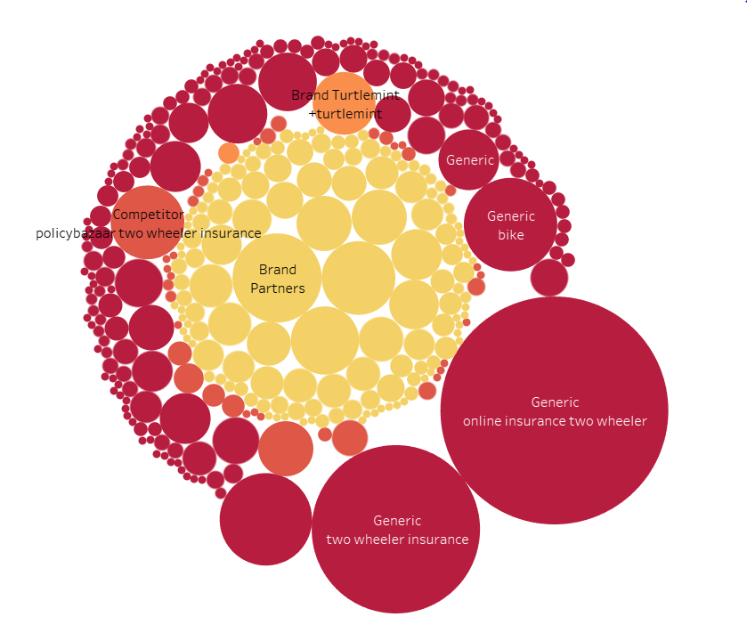

**Fig 2: Screenshot for Visualization 7**

1. Clicks vs Conversions for Generic Keyword Themes using **Bar Chart and Line Chart**:

As mentioned earlier, the combination of line chart and bar charts effectively depicts the visualization of a single variable against two different but related variables. Here, we wanted to understand the clicks and conversions on 21 different keyword themes to understand the effects and relation of each keyword theme on/with clicks and conversions.

1. Campaign Type Average Position across Months using **Bar Chart and Line Chart**:

In this visualization, we wanted to study the effect of position on conversion. In addition to these two variables, our interest was in visualizing the trends across different months to get more clarity on the relation of these variables.

1. Keyword Type and respective Average Bounce Rates using **Bar Chart and Line Chart**:

Here we are visualizing Bounce Rate and sessions for each of the 6 months across different keyword types. Visualizing all these variables using any other technique will not reveal clear insights therefore this visualization is done using bar and line chart.

1. Campaign type and respective Bounce rates using **Area Chart and Line Chart:**

Area charts and line charts are the best methods to visualize time series data. To visualize Bounce rate and session for different campaign types along the period of 6 months, it was the best suited to use area and line charts together for a better understanding of the trends.

**Discussion of the Storyline Chosen:**

Stories play a major role in making the audience and people understand the visualization in a better way. We have chosen to deliver our story of the Top 2- wheeler Insurance aggregator by breaking it down into the following parts:

1. **Set the stage**

Our major goal from the visualization was to observe the trends of how different ads perform and effect a business. We observed different parameters like Clicks, click through transactions, Impressions etc. to get a clarity on the role they play in the success of an ad. We started with by giving a brief explanation about the dataset chosen. We also introduced some of key terminologies used related to the AdWords data. We gave a small description of our 2- wheeler insurance brand partners whose data visualization has been carried out.

1. **Observing different attributes and understanding their relations:**

After building the base, we explained the role of different variables amongst different campaign types and how each of them effects the performance of an ad.

* Does clicks effects impressions.
* Are bounce rates affecting each campaign types?
* What importance does keywords play in the success of an ad.

These along with the other importance trends were visualized and narrated in the story to understand the success of an ad campaign and its relation with different variables.

1. **Conclusion:**

We came up with few important conclusions that will improve the ad rank. Also, the conversion rates play an important role in the success of an ad. We concluded the story keeping in mind the major variables affecting the ad rank and success and what parameters can be improved upon in our brand campaigns for a better ad success.

**Visual Data Narrative Process:**

1. **Audience**

We engaged the audience/viewers who are aware and unaware of the concepts of Digital Marketing SEM (Google AdWords), viewers who are frequently go online and search for things on Google Search Engine Result Page. We engaged all audience by highlighting the details about Keyword trend and Insights for an Online Insurance Aggregator in India.

1. **Evidence**

We present appropriate visualizations and data to support the claims. We demonstrated the knowledge we gained through the visualization in an progressive way. We layered the information to unfold the sort in a way which grabs the attention of a user in an interesting way and reveal important trends and facts. We achieved this by compounding builds in visualization and by sequencing different types of visualizations.

1. **Rhetorical Argument**

Logical arguments and conclusions are taken into consideration for optimization of the campaigns also we have highlighted general trends of Digital marketing in India location. We recommended that it is better to create thematic keyword themes across different campaigns, match types and keyword bids.

1. **Narrative Structure**

As mentioned above, we incorporated setting the scene by giving a brief introduction on organizational data across AdWords and Analytics. Challenges are defined, if we bid based on generalizations for each individual campaign. Finally, we recommended ways to understand the complexity in the data by providing visualizations which discusses the outcomes of current set of campaigns and the importance of carefully aligning the campaign structure and the subsequent keywords.

**Description of Insights:**

**Visualization 1**:

Monthly Overview of Two-Wheeler Insurance Aggregator (Search Campaigns) from Jan 2018 to June 2018

* Number of Clicks has fallen by 39% from March-18 to June-18 this has led to 44% drop in Conversions during the same period.

**Visualization 2:**

Impressions Trend Across Campaign Type and Months

* The Impression Volume for Brand, Brand Partner & Competitor Campaigns have remains similar across months however there is a huge drop (50%) in Generic Set of Campaigns, this has led to drop in Clicks and further Conversion.

**Visualization 3:**

Campaign Level Conversion vs Conversion Rate

* Conversions Rate for Generic & Competitor campaigns have improved over the month; however, number of Conversions for Generic have dropped by 53% from March to June. The CVR for Brand campaigns have dropped, which is a cause of worry.

**Visualization 4:**

Campaign Level Conversion vs Cost Per Click (CPC) & Click Through Rate (CTR)

* The CPCs have shot up 2x from April to June across the campaign types, however the CTR improvement can only be seen in Brand Campaigns.

**Visualization 5:**

Keyword Type Data: Clicks vs Conversions

* Exact Match Keyword Type has the best conversion rate of 4.5% followed by phrase match (3.9%) & broad match (3%) type keywords.

**Visualization 6:**

Top 5 performing keywords based on match levels.

**Conversion for Phrase Match:**

* Two-wheeler insurance keyword conversions were the highest followed by the Bajaj Allianz two-wheeler insurance.

**Conversion for Broad Match:**

* +bike +insurance keyword had the highest conversion in the top 5 keyword category accounting for 34% of the conversion rate.

**Conversion for Exact Match**

* Online insurance two-wheeler keyword conversions were the highest in the exact match category.

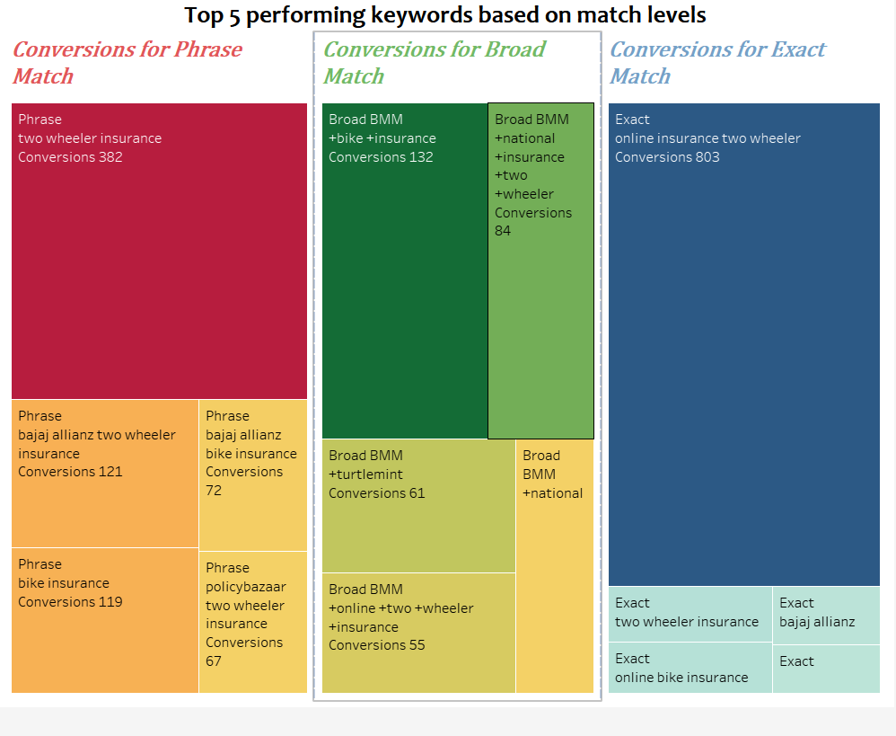

**Fig 3: Screenshot for Visualization 6**

**Visualization 7:**

Keyword Conversions based on Campaign type (Brand, Brand Partners, Competitor & Generic)

* For Brand campaigns, Turtlemint (exact) & +turtlemint +insurance is leading to max. conversions.
* Online KW theme has the maximum conversions in the Generic Campaign Types.

**Visualization 8:**

Clicks vs Conversions for Generic Keyword Themes

* 84% of conversions in Generic Set of Campaigns are coming in from top 5 Keyword Themes, Top Keyword themes as per the conversion rate are Online, Two-Wheeler, Renewal & Scooter Insurance.

**Visualization 9:**

Campaign Type Average Position across Months

* The Average Position for Brand Partners, Competitor & Generic Campaigns have increased gradually over the months and a downward trend of conversions can be observed here, for Brand campaigns the Average position in June has increased by 1.6x compared to May, effort must be put in to improve the Average Positions across campaigns.

**Visualization 10:**

Keyword Type and respective Average Bounce Rates

* The Bounce rate trend across the months for each KW type is similar, however in the month of June the BR for Exact match and Phrase match type is 25% higher compared to Broad match type, typically the BR for Exact match should be comparatively lower than Broad match types.

**Visualization 11:**

Campaign type and respective Bounce rates

* The Bounce Rate for Brand Campaign has increased across months, however the sessions reported against these campaigns are very low and the validation of the data needs to be carried out, an increased trend in BR is also seen in Generic set of campaigns.

**Final Insights from the Analysis:**

The client/brand should work on the following to optimize the campaign:

1. The average positions across different campaign types (except Brand) is less than 2.9. Therefore, if the average positions are improved in all the campaign types, it will lead to a high Ad rank thereby improving the Click through Rates (CTR) and conversions.
2. The Cost per Click (CPC) on Exact match keywords is higher than the Broad match keywords, considering conversion rates and improving on the CPCs will reduce the Overall cost per transaction by 35%
3. The Cost per Transaction (CPT) for competitor campaigns has improved by 40% in the span of 6 months, however the scale on the campaigns is limited. The increase in the scale of these campaigns will increase the overall conversion volumes by more than 10%.